**Design Thinking Project Workbook**

**1. Team**

**Team Name: 404-NotFound**

**Team Logo (if any):**

**Team Members:**

1. Nula Swathi, Team Lead, 2320030201@klh.edu.in
2. N.Nandini, Technical, [2320030459@klh.edu.in](mailto:2320030459@klh.edu.in)
3. P.N.Vedha Sree, Technical, 2320030269@klh.edu.in

**2. Problem/Opportunity Domain**

**Domain of Interest: Online Education System**

**Description of the Domain:**

**Key Components:**

**Course Management: Manages course creation, content delivery, and structure.**

**Analytics and Reporting:** **racks progress, performance, and generates reports.**

**Content Delivery: Supports multimedia content like videos, articles, and written notes.**

**Security Features: Protects data and ensures privacy.**

**Functionalities:**

* **Interactive Learning Modules: Engage user with videos, quizzes.**
* **Automated Grading: Instant feedback on quizzes.**
* **Progress Tracking: Monitor student progress and performance.**
* **Check task progress (e.g., “What’s on my to-do list?”).**

**Benefits:**

* **Cost-Effective.**
* **Scalability.**
* **Immediate Feedback.**

**Why did you choose this domain?:**

**Efficiency and Productivity:Task management systems streamline workflow, ensuring that tasks are organized, prioritized, and tracked efficiently. This helps individuals and teams stay productive and meet their goals.**

**Scalability:Both online education and task management systems can easily scale to accommodate growing numbers of users and content, ensuring they remain effective as needs evolve.**

**Accessibility:Online education breaks down geographical barriers, allowing people from all over the world to access quality education. It's about making learning opportunities available to everyone, regardless of location.**

**TechnologicalInnovation:Online learning platforms, virtual classrooms, and interactive content make education more flexible and inclusive.**

**3. Problem/Opportunity Statement**

**Problem Statement:**

**Context:Traditional education systems face numerous challenges, such as limited access, inflexible schedules, and high costs. These barriers prevent many individuals from pursuing further education and skill development, leading to skill gaps in various industries and limiting personal growth opportunities.**

**Problem:** **Students and professionals often face challenges in accessing quality education due to time constraints, geographical barriers, and high costs. The need for flexible and accessible learning solutions has become increasingly critical. Existing education systems often lack the convenience of online learning, leading to missed opportunities, knowledge gaps, and increased stress in balancing education with other responsibilities.**

**Objectives:**

1. **Ensure that quality education is available to learners regardless of their geographical location or time constraints.**
2. **Provide learning options that can be adapted to individual schedules, allowing  for self-paced and on-demand learning.**
3. **Reduce the financial barriers to education by providing affordable learning solutions without compromising quality.**
4. **Track and analyze learner progress to offer personalized feedback and improve the overall learning experience.**
5. **Implement robust security measures to protect user data and maintain privacy.**

**Problem Description:**

**Key Challenges:**

**1.Ensuring Engagement: Keeping students motivated and engaged through online content.**

**2.Maintaining Quality:**

**Delivering high-quality, interactive, and effective educational materials..**

**3.Technical Issues:**

**Addressing connectivity problems and ensuring platform reliability.**

**4.Data Security:**

**Protecting user data and maintaining privacy.**

**5.Personalization:**

**Tailoring learning experiences to individual needs and learning styles.**

**Context (When does the problem occur):**

**Limited Access to Quality Education:**

* **This problem often occurs in remote or underdeveloped areas where there are few educational institutions and limited access to qualified instructors.**

**Inflexible Schedules:**

* **Students and working professionals face this issue when they have rigid schedules that prevent them from attending traditional inperson classes, making it difficult to pursue further education.**

**High Costs:**

* **The problem arises when the cost of traditional education, including tuition, textbooks, and commuting, is prohibitive for many individuals, limiting their ability to continue learning.**

**Real-time Feedback and Interaction:**

* **The lack of realtime interaction and immediate feedback, which are often present in traditional classrooms, can pose a problem in online education settings.**

**Alternatives (What does the customer do to fix the problem):**

**Paper Lists/Planners:**

* **Some users may resort to traditional paper planners to manage their tasks quickly.**

**Simpler Digital Tools:**

* **Users might opt for simpler, faster-to-use digital tools like sticky notes or basic to-do list apps.**

**Assistive Technologies:**

* **Users may use screen readers, voice recognition software, or other assistive technologies to help navigate traditional task management tools.**

**Delegating Tasks::**

* **Users might delegate tasks to others to reduce their cognitive load.**

**Customers (Who has the problem most often):**

**Students:**

* **Struggle with accessing quality education due to time constraints, geographical barriers, and high costs.**

**Working Professionals:**

* **Face challenges in attending traditional classes due to demanding work schedules.**

**Emotional Impact (How does the customer feel):**

**Overwhelmed:**

* **Balancing studies with other responsibilities can lead to feelings of being overwhelmed.**

**Frustrated:**

* **They feel frustrated by the lack of flexible learning options and access to quality education.**

**Quantifiable Impact (What is the measurable impact):**

**Productivity Loss:**

* **Reduced Time on Task Management: Decreased hours spent manually entering and organizing tasks, leading to more time spent on actual work.**
* **Lowered administrative costs associated with managing and updating tasks manually.**
* **Missed Deadlines:**
* **Reduction in the number of missed deadlines due to improved task tracking and automated reminders.**
* **Increase in the percentage of projects and tasks completed on or before the deadline.**

**Alternative Shortcomings (What are the disadvantages of the alternatives): •**

**Assistive Technologies:**

* **Not all traditional task management tools are compatible with assistive technologies.**
* **Risk of Loss: Paper lists can be easily misplaced, torn, or lost, leading to forgotten tasks.**

**Basic Task Management Apps:**

* **Limited Functionality: Many basic apps lack advanced features such as reminders, prioritization, or categorization, making them less effective for complex task management.**
* **High-quality assistive technologies can be expensive.**

**Any Video or Images to showcase the problem:**

1. **Addressing SDGs**

**Relevant Sustainable Development Goals (SDGs):**

**SDG 3: Good Health and Well-Being**

**Ocuses on ensuring healthy lives and promoting well-being for all at all ages. An online education system can play a crucial role in achieving this goal by providing accessible, high-quality health education and resources.**

**SDG 4: Quality Education**

**Aims to ensure inclusive and equitable quality education and promote lifelong learning opportunities for all. An online education system can significantly contribute to achieving this goal by leveraging technology to provide accessible and high-quality learning experiences.**

**How does your problem/opportunity address these SDGs?:**

**SDG 3: Lifelong Learning Opportunities:**

* **Impact: Offer a wide range of subjects and skill levels to cater to different learning interests and needs.**
* **SDG 4: Quality Education**
* **Impact: Students can utilize the voice-activated system to manage their academic responsibilities more effectively, enhancing their learning experience and improving grades. This accessibility can also support lifelong learning for individuals of all ages.**

1. **Stakeholders**

Answer these below questions to understand the stakeholder related to your project

1. **Who are the key stakeholders involved in or affected by this project?**

**Project Team Members**: This includes project managers, developers, designers, and testers who are directly involved in executing the project.

**Clients/Customers**: The individuals or organizations who will use the end product or service. Their needs and feedback are crucial for project success.

2.**What roles do the stakeholders play in the success of the innovation?**

**Project Team Members**:

* **Execution**:Responsible for the design, development, and implementation of the innovation.
* **Problem-Solving**:Address challenges and ensure quality throughout the project lifecycle.
* **Feedback Loop**: Provide insights from the technical side that can refine the innovation.

**Clients/Customers**:

* **Requirements Definition**: Help shape the innovation by providing input on needs and preferences.
* **User Testing**: Engage in testing phases to provide feedback on usability and functionality.
* **Adoption**: Their willingness to use the innovation is crucial for its market success.

3.**What are the main interests and concerns of each stakeholder?**

**Project Team Members**:

**Interests**: Successful project completion, skill development, collaboration, recognition for their work.

**Concerns**: Workload management, project deadlines, resource availability, quality of work, and team dynamics.

**Clients/Customers**:

**Interests**: High-quality products/services that meet their needs, value for money, positive user experience.

**Concerns**: Reliability, customer support, pricing, the responsiveness of the company, and the product’s performance.

1. **How much influence does each stakeholder have on the outcome of the project?**

**Project Team Members**:

**Influence**: **High**

**Reason**: Directly responsible for executing the project, making technical decisions, and solving problems. Their expertise and collaboration are critical to the project's success.

**Clients/Customers**:

**Influence**: **High**

**Reason**: Their feedback shapes the product development, and their satisfaction determines market success. Clients can significantly impact the project scope through their requirements.

3.**What is the level of engagement or support expected from each stakeholder?**

**Project Team Members**:

**Expected Engagement**: **High**

**Details**: Active participation in project planning, execution, and feedback sessions. Continuous collaboration and communication within the team are essential for project success.

**Clients/Customers**:

**Expected Engagement**: **Moderate to High**

**Details**: Regular feedback during the development process, participation in user testing, and input on requirements and preferences. They should be engaged in decision-making, especially regarding features and usability

3.**Are there any conflicts of interest between stakeholders? If so, how can they be addressed?**

**Resource Allocation**:

**Conflict**: Stakeholders may compete for limited resources (budget, personnel, time) based on their own priorities.

**Addressing**: Establish clear resource allocation criteria and involve stakeholders in discussions about prioritization to ensure transparency and fairness.

**Project Scope**:

**Conflict**: Clients may want to add features or changes that can increase costs and timelines, while management may be focused on staying within budget and deadlines.

**Addressing**: Implement a change management process that evaluates the impact of scope changes on resources, timelines, and budgets, allowing for informed decision-making.

3.**How will you communicate and collaborate with stakeholders throughout the project?**

**1. Communication Plan**

**Establish Clear Channels**: Identify the most effective communication channels for each stakeholder group (e.g., email, instant messaging, project management tools, in-person meetings).

**Frequency of Communication**: Define how often you will communicate with stakeholders (e.g., weekly updates, monthly reviews) based on their level of engagement and interest.

**Information Types**: Specify the types of information to be shared (project updates, milestones achieved, risks identified, etc.).

**2. Regular Updates**

**Status Reports**: Send regular status reports summarizing project progress, milestones achieved, and any challenges faced. Tailor these reports to the specific interests of different stakeholders.

**Meetings**: Schedule regular meetings (virtual or in-person) to discuss progress, gather feedback, and address concerns. Use these meetings to encourage open dialogue.

**Dashboards**: Create visual dashboards using project management tools to provide real-time updates on project status and key performance indicators (KPIs).

3.**What potential risks do stakeholders bring to the project, and how can these be mitigated?**

**Project Team Members**

**Potential Risks**:

**Skill Gaps**: Team members may lack necessary skills, impacting quality and timelines.

**Burnout**: High workload and stress can lead to decreased productivity and morale.

**Mitigation Strategies**:

**Training and Development**: Provide necessary training to fill skill gaps.

**Workload Management**: Monitor workloads and redistribute tasks to prevent burnout.

**2. Clients/Customers**

**Potential Risks**:

**Changing Requirements**: Clients may frequently change requirements, leading to scope creep.

**Dissatisfaction**: Misalignment between client expectations and deliverables can result in dissatisfaction.

**Mitigation Strategies**:

**Clear Scope Definition**: Establish a clear project scope and change management process.

**Regular Check-ins**: Maintain regular communication to manage expectations and gather feedback.

**5. Power Interest Matrix of Stakeholders**

**Power Interest Matrix:**

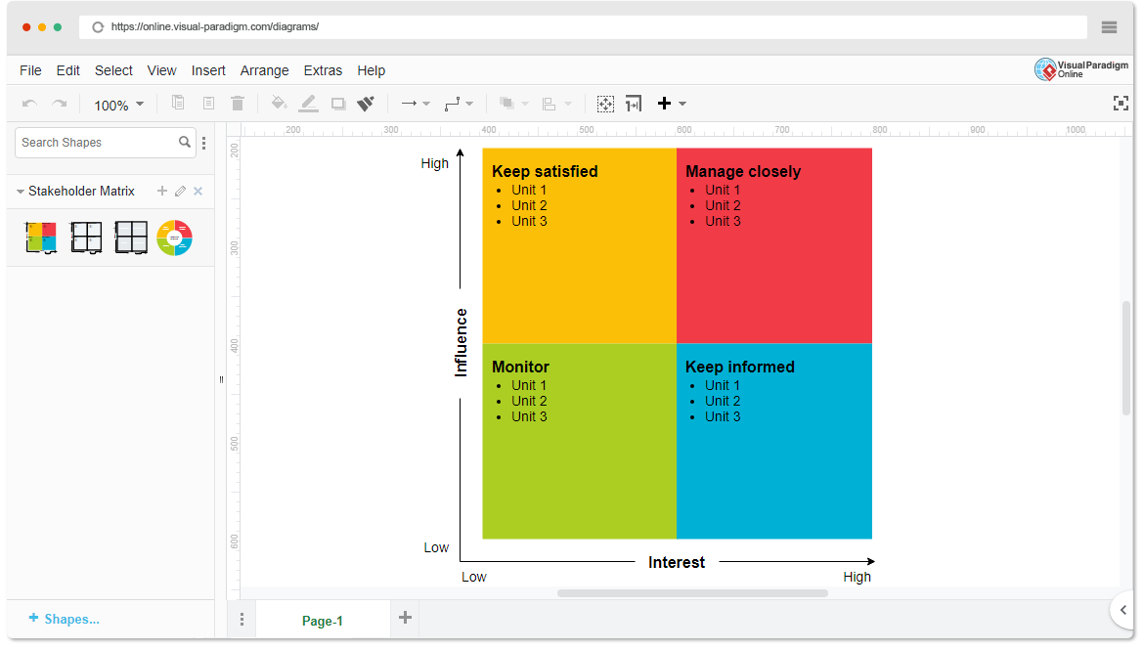

* High Power, High Interest: Product Owner, Project Sponsor, Technical Lead.
* High Power, Low Interest: Executive Management, Compliance/Legal Team.
* Low Power, High Interest: End Users(Student, Instructor), Customer Support Team.
* Low Power, Low Interest: Third-party Vendors, General IT Support.

7.**Empathetic Interviews**

**Conduct Skilled interview with at least 30 citizens/Users by asking open ended questions (What, why/How etc) and list the insights as per the format below**

|  |  |  |
| --- | --- | --- |
| **I need to know**  **(thoughts, feelings, actions)** | **Questions I will ask**  **(open questions)** | **Insights I hope to gain** |
| Thoughts | *What are your thoughts on [topic/feature]?* *Why do you think [aspect] is important?* | Understand users’ opinions and beliefs related to the topic and any preconceived notions they might have. |
|  |  |  |
|  |  |  |
| Feelings | *How does [issue/feature] make you feel?* *What are your emotions when you face [problem] in daily life?* | Gauge users' emotional responses to challenges or features, providing insight into what impacts them personally. |
|  |  |  |
|  |  |  |
| actions | *How do you usually handle [situation]?* *What steps do you take to [achieve a goal] or deal with [issue]?* | Learn about current behaviors and strategies users employ to accomplish tasks or overcome obstacles. |
|  |  |  |
|  |  |  |

**SKILLED INTERVIEW REPORT**

**(Examples are given. Erase them and fill with your user information.)**

|  |  |  |
| --- | --- | --- |
| **User/Interviewee** | **Questions Asked** | **Insights gained (NOT THEIR ANSWERS)** |
| Freelancer | What are your thoughts on managing tasks with voice commands? | Users may have concerns about privacy and accuracy of voice recognition in public spaces. |
| Busy Professional | How do you feel about using voice commands for quick task management? | Some users feel that voice commands could help save time, especially when multitasking. |
| Retired | What steps do you take to organize your daily tasks currently? | Older users might prefer traditional methods over technology, indicating a need for optional manual input. |
|  |  |  |
|  |  |  |

**Key Insights Gained:**

* **Insight 1: Privacy and security concerns are prevalent among users when it comes to using voice commands in public or shared spaces.**
* **Insight 2: Users are interested in using voice commands for multitasking but require high accuracy and responsiveness.**
* **Insight 3: Traditional task management methods are still preferred by some users, suggesting the need for alternative input options.**

**Empathy Map**

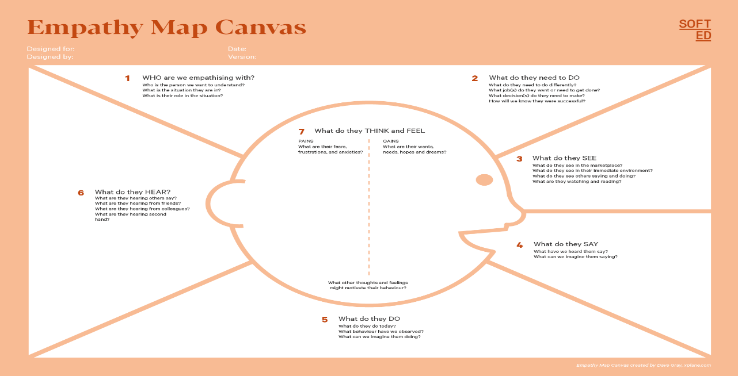

Your Answer:

Your Answer:

Who is your Customer Segment:

Idea/Innovation Title:

Designed By:

Date of Submission:

Your Answer:

Your Answer:

Your Answer:

Your Answer:

Your Answer:

Your Answer:

Your Answer:

1. **Empathy Map**

**a. Who is your Customer?  
We empathize with clients, end users, project team members, management, investors, regulatory bodies, suppliers, the community, stakeholder advocates, and project sponsors.**

**b. Who are we empathizing with?  
They need to communicate needs, collaborate, provide feedback, ensure compliance, and support project goals.**

**c. What do they need to DO?  
They review updates, monitor deliverables, interact with stakeholders, and assess market trends and community impacts.**

**d. What do they SEE?  
They see project updates, deliverables, stakeholder interactions, compliance requirements, and user experiences.**

**e. What do they SAY?  
They provide feedback, voice concerns about timelines, and express expectations for project outcomes.**

**f. What do they DO?  
They participate in meetings, provide feedback, collaborate, ensure compliance, and advocate for interests.**

**g. What do they HEAR?  
They hear project updates, stakeholder feedback, team discussions, regulatory guidelines, and market insights.**

**h. What do they THINK and FEEL?  
They think about project success and feel concerned about risks while hoping for alignment among stakeholders.**

**i. Pains and Gains  
Pains include resource constraints and compliance challenges, while gains encompass successful outcomes and enhanced user satisfaction.**

**8. Persona of Stakeholders**

**Demographics: Diverse stakeholders aged 25-55, typically college-educated professionals in urban areas, from middle to upper-middle socioeconomic status.**

**Goals: Achieve project success, meet client needs, enhance user experience, ensure compliance, and maximize ROI.**

**Challenges: Manage expectations, navigate resource limitations, ensure communication, and address regulatory compliance.**

**Aspirations: Drive innovation, foster collaboration, achieve excellence, and create a positive impact on users and the community.**

**Needs: Clear communication, adequate resources, timely feedback, user engagement, and effective collaboration.**

**Pain Points: Miscommunication, conflicting priorities, delays in decision-making, limited resources, and inadequate engagement.**

**Storytelling: Create a compelling narrative to emotionally connect stakeholders to the project, highlighting its purpose and transformative impact.**

**Sample:**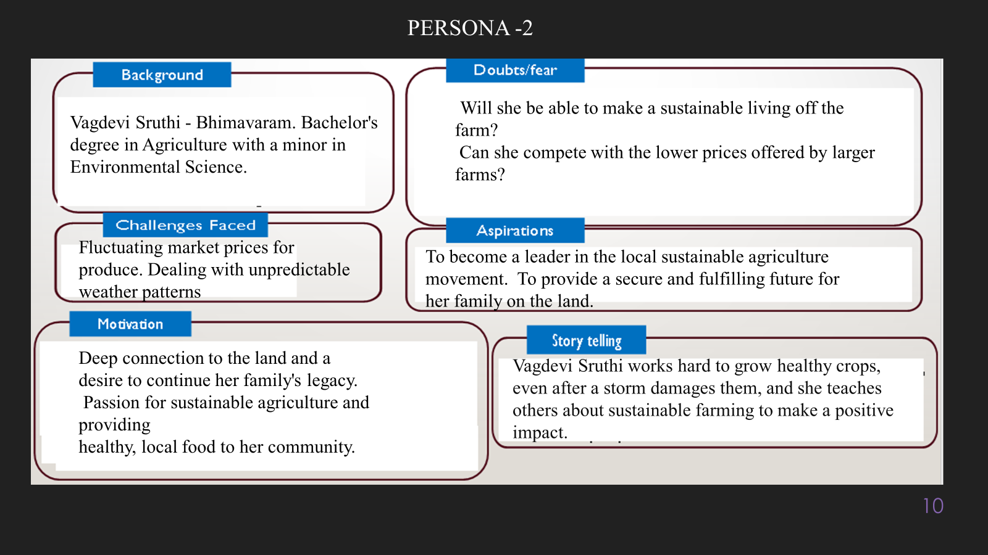

**10. Look for Common Themes, Behaviors, Needs, and Pain Points among the Users**

Analyse the data from your affinity diagram to uncover recurring patterns among your users, helping you better understand their expectations and challenges.

**Common Themes: Users prioritize simplicity and efficiency in task management, seeking intuitive interfaces that make adding and organizing tasks easy. They also value integration with daily routines, preferring solutions that seamlessly fit into their lives.**

**Common Behaviors: Users frequently utilize voice commands to quickly add or update tasks, especially when multitasking or engaged in other activities. They expect immediate feedback from the system after issuing commands, reinforcing their desire for a responsive interaction.**

**Common Needs: Users require high accuracy in voice recognition to ensure their spoken commands are transcribed correctly, minimizing errors. Additionally, they desire customizable task features, such as categorization and reminders, to enhance their organizational capabilities.**

**Common Pain Points: Users often experience frustration when the system misinterprets voice commands, leading to incorrect task entries. They also report dissatisfaction with slow system responses, which disrupts their workflow and hinders task management efficiency.**

**12. Define Needs and Insights of Your Users**

**User Needs:**

**Functional Needs:**

* **Users require high accuracy in voice recognition to ensure their spoken commands are transcribed correctly without misunderstandings. They also need essential task management features, such as adding, editing, categorizing, and setting reminders, which help improve their organizational capabilities.**

**Emotional Needs:**

* **A straightforward and intuitive interface is crucial for users to reduce frustration and encourage regular use of the system. Additionally, they seek confidence in the technology, desiring a reliable system that minimizes anxiety around task management and ensures tasks are handled effectively.**

**Societal Needs:**

* **The solution must cater to diverse user groups, including those with disabilities or varying tech skills, promoting accessibility and inclusivity. Furthermore, users require seamless synchronization across devices to ensure consistent task management, allowing them to switch between devices without losing data.**

**User Insights:**

**Motivations:**

**Users are motivated by the desire for efficiency in their daily routines, as they value tools that streamline task management and save time for other activities. This drive for efficiency leads them to seek out solutions that integrate well into their lifestyles.**

**Behavior Patterns:**

**Many users exhibit a strong preference for voice commands over manual input, especially when multitasking or engaged in other activities. This behavior indicates a clear need for hands-free solutions that allow them to manage tasks without interrupting their flow.**

**Pain Points:**

**Users frequently experience frustration due to misinterpretation of voice commands and slow system responses, which diminish their trust in the technology. These pain points can lead to decreased user satisfaction and a reluctance to fully engage with the task management system.**

**Decision Drivers:**

**When choosing a solution, users are likely to prioritize quick and reliable task management with minimal effort required. This emphasis on user experience and technology reliability significantly influences their decision-making process, driving them towards tools that offer effective and efficient task management.**

**13. POV Statements**

**POV Statements:**

* [User] needs a way to [need] because [insight].

|  |  |  |  |
| --- | --- | --- | --- |
| PoV Statements  (At least ten) | Role-based or Situation-Based | Benefit, Way to Benefit,  Job TBD,  Need (more/less) | PoV Questions  (At least one per statement) |
| A busy professional needs a way to quickly add tasks using voice commands because they often juggle multiple responsibilities and need to manage their time efficiently. | Busy Professional | Improved time management and reduced stress. | What can we design that allows busy professionals to seamlessly add tasks while multitasking? |
| A student needs an intuitive interface for managing assignments and deadlines because they want to stay organized and avoid last-minute stress before exams. | Student | Better organization and academic performance. | What can we create to help students efficiently track their assignments and manage deadlines? |
| A parent needs a reliable system to set reminders for family activities and events because they often forget important dates and want to ensure nothing slips through the cracks. | Parent | Enhanced family organization and peace of mind. | How can we design a feature that helps parents remember and manage family activities effortlessly? |
| A tech-savvy individual needs advanced voice recognition capabilities because they seek a more efficient way to manage tasks without manual input. | Tech-Savvy Individual | Increased productivity and satisfaction with technology. | What can we implement that enhances voice recognition accuracy for tech-savvy users? |
| A visually impaired user needs a voice-based task management system that is accessible because they want to manage their tasks independently without needing visual input. | Visually Impaired User | Empowerment and independence in task management. | How can we ensure our task management system is fully accessible for visually impaired users? |
| A remote worker needs a synchronized task management system across multiple devices because they switch between devices throughout the day and need consistency in task tracking. | Remote Worker | Streamlined workflow and reduced confusion. | What can we design that ensures seamless synchronization of tasks across all user devices? |
| An elderly user needs an easy-to-use interface with clear voice commands because they may find technology challenging and need a straightforward solution to manage tasks. | Elderly User | Increased user confidence and reduced frustration. | How can we create a user-friendly interface that simplifies task management for elderly users? |
| A project manager needs the ability to categorize tasks by project because they need to keep track of multiple projects and ensure nothing is overlooked. | Project Manager | Enhanced project organization and efficiency. | What features can we develop that help project managers categorize and prioritize tasks efficiently? |
| A fitness enthusiast needs a way to log workouts and fitness goals through voice commands because they want to maintain an active lifestyle without interrupting their routines. | Fitness Enthusiast | Simplified fitness tracking and motivation. | How can we design a voice logging feature that seamlessly integrates with users' fitness activities? |
| A time management coach needs insights on user task management patterns because they want to provide tailored advice to clients on improving productivity. | Time Management Coach | Enhanced coaching effectiveness and client satisfaction. | What can we implement that gives coaches access to user task management data for better guidance? |

**14. Develop POV/How Might We (HMW) Questions to Transform Insights/Needs into Opportunities for Design**

Turn your user needs and insights into actionable opportunities by framing them as "How Might We" (HMW) questions. These questions will spark creative problem-solving and guide your innovation process.

1. **How Might We: Based on the needs and insights you've identified, create open-ended questions starting with "How might we...?" These questions should aim to solve user pain points, enhance the experience, or address specific needs.**

**Examples:**

* **User Need:**
* **Users need a quick and simple way to add tasks without having to interact with the screen.**
* **Users may need to categorize or prioritize tasks for better organization.  
  HMW Question: *How might we create an intuitive way for users to categorize and prioritize tasks automatically through voice commands?***
* **Insight: Users often want to be reminded of tasks at specific times or locations.  
  HMW Question: *How might we let users set smart reminders through voice, triggered by time or location, to enhance task relevance?***
* **Users want to edit or complete tasks quickly without navigating complex options.  
  HMW Question: *How might we allow users to manage tasks (edit, mark as complete, delete) using simple and efficient voice commands?***
* **Task:**

**Write 3-5 "How Might We" questions based on your analysis of user needs and insights. These questions should challenge you to think of innovative solutions that can address user problems in meaningful ways.**

**This task encourages participants to think creatively about solving user problems, transforming challenges into opportunities for innovation.**

|  |  |
| --- | --- |
| User Need/Insight | "How Might We" Question |
| Users may want to quickly add tasks without navigating menus.  Users may struggle to manage multiple tasks and priorities.  Users may find it difficult to edit or delete tasks using voice.  Users might need reminders but don't want excessive notifications. | **How might we allow users to add tasks with minimal effort, directly using their voice?**  **How might we help users prioritize tasks easily through voice commands?**  **How might we enable users to manage, edit, and delete tasks seamlessly through voice alone?**  **How might we design a gentle, customizable reminder system that users can set via voice commands?** |
|  |  |

**16. Crafting a Balanced and Actionable Design Challenge**

The Design Challenge Should Neither Be Too Narrow Nor Too Broad and It Should Be an Actionable Statement with a quantifiable goal. It should be a culmination of the POV questions developed.

**Design Challenge: *Create a voice-based task management system that enables users to add, organize, and manage tasks hands-free with an intuitive interface. The system should support smart categorization, time- and location-based reminders, and offer a discreet mode for public settings, achieving a 90% user satisfaction rate for ease of use within three months of deployment.***

**This challenge is actionable, with a clear goal and measurable outcome, focusing on enhancing user convenience and adaptability in various settings.**

**17. Validating the Problem Statement with Stakeholders for Alignment**

Ensure your problem statement accurately represents the needs and concerns of your stakeholders and users. This involves gathering feedback from these groups to confirm that the problem is relevant and significant from their perspective. By validating early, you can refine the problem statement to better align with real-world challenges, ensuring your solution addresses the correct issues.

**Validation Plan:**

**Stakeholder/User Feedback (Min. 10 Stakeholders/Experts):**

|  |  |  |  |
| --- | --- | --- | --- |
| Stakeholder/User | Role | Feedback on Problem Statement | Suggestions for Improvement |
| Product Manager | **Oversees product goals** | **Problem resonates as it aligns with user demands for hands-free task management but could highlight privacy needs.** | **Emphasize security measures and options for using the app in public settings.** |
| UX Designer  Target User Group  Accessibility Specialist  IT Security Expert | **User experience expert**  **Busy professionals**  **Ensures app inclusivity**  **Cybersecurity advisor** | **Sees value in voice-based hands-free design; clear statement but could clarify the primary user workflow.**  **Problem is relevant; they need fast, hands-free options for task updates on the go.**  **Agrees it’s relevant, but it should emphasize inclusive design for users with limited mobility.**  **Supports problem; users value convenience but need assurance of data security, especially for sensitive info.** | **Specify which core functions should be accessible hands-free.**  **Include a “priority tagging” feature to aid quick task prioritization.**  **Mention accessibility options to address various user abilities.**  **Suggest addressing data encryption for task entries and reminders.** |

**18. Ideation**

**Ideation Process:**

|  |  |  |  |
| --- | --- | --- | --- |
| Idea Number | Proposed Solution | Key Features/Benefits | Challenges/Concerns |
| Idea 1 | **Hands-Free Task Addition and Management** | **Allows users to add, edit, and manage tasks entirely through voice commands, improving productivity.** | **Ensuring high accuracy of speech recognition in various accents, noise levels, and languages.** |
| Idea 2 | **Smart Task Categorization and Prioritization** | **Automatically categorizes tasks based on keywords and suggests priorities, aiding better task organization.** | **Implementing reliable natural language processing (NLP) to accurately interpret context and importance.** |
| Idea 3 | **Contextual Reminders (Time & Location-Based)** | **Offers reminders based on time or user location, enhancing task relevance and timeliness.** | **Requires user permission for location data, which may raise privacy concerns; ensuring reminder accuracy.** |
| Idea 4 | **Discreet Mode for Public Settings** | **Provides a quiet interaction mode for privacy in public spaces, allowing screen-tap or whispered commands for discretion.** | **Balancing discreet interaction with effectiveness, especially in noisy environments.** |
| Idea 5 | **Adaptive Voice Recognition Based on Environment** | **Adjusts voice recognition sensitivity based on environmental noise, enhancing accuracy in diverse settings.** | **Developing adaptive algorithms to detect noise levels and modify sensitivity in real time.** |

**18. Idea Evaluation**

Evaluate the Idea based on 10/100/1000 grams

|  |  |  |  |  |
| --- | --- | --- | --- | --- |
| Idea | Impact (10/100/1000 grams) | Feasibility (10/100/1000 grams) | Alignment (10/100/1000 grams) | Total Weight |
| Idea 1 | **1000** | **1000** | **1000** | **3000** |
| Idea 2 | **1000** | **100** | **1000** | **2100** |
| Idea 3 | **100** | **100** | **1000** | **1200** |
| Idea 4 | **1000** | **100** | **100** | **1200** |
| Idea 5 | **100** | **100** | **1000** | **1200** |

**Example:**

|  |  |  |  |  |
| --- | --- | --- | --- | --- |
| Idea | Impact (10/100/1000 grams) | Feasibility (10/100/1000 grams) | Alignment (10/100/1000 grams) | Total Weight |
| Idea 1 | **1000** | **100** | **1000** | **2100** |
| Idea 2 | **100** | **1000** | **100** | **1200** |
| Idea 3 | **100** | **100** | **100** | **300** |

Further, use solution concept form to scrutinize the idea

**Solution Concept Form**

**1. Problem Statement:**

***Users struggle to efficiently manage tasks hands-free, especially when multitasking or in environments where using traditional touch interfaces is inconvenient or unsafe. They need a reliable, voice-based solution that offers task organization, prioritization, and reminders while respecting privacy in public settings.***

**2. Target Audience:**

**Busy professionals, students, and individuals who frequently multitask or need hands-free solutions for task management. This group includes drivers, people with mobility limitations, and users who prefer voice interfaces.**

**3. Solution Overview:**

**A voice-based task management system that allows users to add, edit, prioritize, and set reminders for tasks entirely through voice commands. This solution leverages advanced speech-to-text and natural language processing to provide a seamless, hands-free experience.**

**4. Key Features:**

| **Feature** | **Description** |
| --- | --- |
| **Feature 1** | **Hands-Free Task Addition and Management - Users can add, edit, and complete tasks using only voice.** |
| **Feature 2** | **Smart Task Categorization and Prioritization - Automatically categorizes tasks based on user input.** |
| **Feature 3** | **Contextual Reminders (Time & Location-Based) - Allows setting reminders triggered by time or location.** |

**5. Benefits:**

| **Benefit** | **Description** |
| --- | --- |
| **Benefit 1** | **Increased Productivity - Enables task management without interrupting other activities.** |
| **Benefit 2** | **Enhanced Accessibility - Provides a hands-free option for users with mobility limitations.** |
| **Benefit 3** | **Context-Driven Reminders - Ensures reminders are relevant, delivered at the right time/place.** |

**6. Unique Value Proposition (UVP):**

***This system stands out by offering an intuitive, hands-free task management solution that caters to users’ need for multitasking and privacy. It combines smart categorization, contextual reminders, and adaptive voice recognition to provide a seamless user experience.***

**7. Key Metrics:**

| **Metric** | **Measurement** |
| --- | --- |
| **Metric 1** | **User Satisfaction - Measured by a feedback survey post-deployment.** |
| **Metric 2** | **Task Completion Rate - Tracks the percentage of tasks added and marked done.** |

**8. Feasibility Assessment:**

***The solution is feasible with current technologies, including available speech-to-text APIs, NLP models, and mobile app integration. While resource-intensive, the project is achievable within a defined timeline, especially by using existing NLP libraries and services.***

**9. Next Steps:**

1. **Prototype Development - Build an initial prototype using available speech-to-text and NLP tools.**
2. **User Testing - Conduct tests with the target audience to refine voice commands, reminders, and privacy features.**
3. **Feedback Collection - Gather insights on usability and adjust based on user feedback.**
4. **Full-Scale Development - Integrate user feedback and develop the complete solution.**
5. **Launch & Iterative Improvements - Roll out the solution and refine based on ongoing user data and feedback.**